

TEMENOS T24

Stream

User Guide

Table of Contents

Detect Shake Gestures Widget <Code>

Introduction 3

Preface 3

Overview 3

Assumptions 3

Getting Started 3

Installation 3

Adding the Detect Shake Gestures Widget 3

Appendix 4

# 

# Introduction

## Preface

This User Guide is intended for Developers and provides the step by step instructions for adding a new custom button called Detect Shake Gestures, in your presentation.

## Overview

The Detect Shake Gestureswidget is makes your device react to a shake gesture.

## Assumptions

It is assumed that you are familiar with the edgeConnect Editors and have working knowledge on edgeConnect.

# Getting Started

## Installation

For installation:

1. Copy **com.temenos.widgets.hybrid.accelerometer.detectGestures** folder in your widgets folder (Ex: /{your project/templates }).
2. Copy the content of **Insert in widget.xml** in your widget.xml file within your project.
3. Make sure the **cordova_loader.js** file is inserted in your template header for the phase where you want to use the **Detect Shake Gestures Button** widget.

Insert ***<script src="$$HTML_LOCATION$/js/cordova/cordova_loader.js"></script>*** in your header TPL.

## Adding the Detect Shake Gestures Widget

To add the Detect Shake Gestures widget:

1. In the **Presentation Editor**, create the button and double-click it. The **Presentation Button Properties** dialog opens.
2. Navigate to the tabs **Appearance** -> **Button.**
3. For the **Display Type** field, you have to select **Detect Shake Gestures**.
4. In **Widget Details** tab, you have to set up the widget settings.

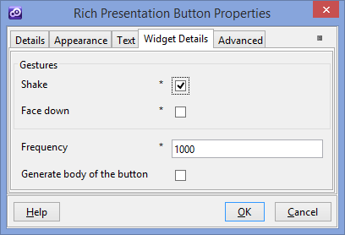

* **Shake** - enables or disables shake gesture detection
* **Face down** - enables or disables face down gesture detection
* **Frequency** -determines how often to retrieve the Acceleration in milliseconds. It is recommended to use the same value for frequency, for each widget instance within your phase.
* **Generate body of button** -enables or disables the generation of the body of the button.

# Appendix

For more technical information, refer to the cordova website: <http://cordova.apache.org/docs/en/3.1.0/cordova_accelerometer_accelerometer.md.html>